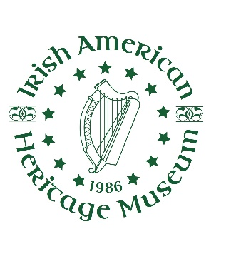
Irish American Heritage Museum
370 Broadway, Albany, NY 12207 (518) 427-1916
www.irish-us.org
Membership Form

Annual membership lasts for a 12 month period and provides the following benefits:

Individual- $50 (Senior/Student- $30)*
- Unlimited admission to Museum and Library
- Discounts on special workshops/classes
- Access to the Museum’s e-newsletter
- Members only e-mails
- 10% Museum Shop discount
- 20% holiday double discount week for Museum Shop

Family- $75
- All benefits of Individual level membership for family, plus
- Participation in the Empire State Reciprocal Program (Free admission to 19 New York State located museums!)

Associate- $100
- All benefits of a Family level membership, plus
- Participation in the North American Reciprocal Program (Free admission to 842 Museums in North America)
- One-on-one session with Museum genealogist

Sustaining- $250
- All benefits of an Associate level membership, plus
- 20% year round discount for Museum Shop
- Special invitations to exhibit openings
- Special discount rates to select events

Sponsor- $500
- All benefits of a Sustaining level membership, plus
- Irish American Heritage Museum Membership Gift
- Two complimentary individual memberships for friends or relatives

Patron- $1,000
- All benefits of a Sponsor level membership, plus
- Special discount rental fee for use of the Museum
- Framed print from the exhibit Dublin Then and Now, which was on display at the National Library of Ireland in Dublin
Name________________________________________________________

Address_______________________________________________________

City/State/Zip__________________________________________________

Phone________________________________________________________

E-mail_______________________________________________________
Membership Level
□$30-Senior/Student
□$50- Individual
□$75- Family
□$100- Associate
□$250- Sustaining
□$500- Sponsor
□$1000- Patron
Please make checks payable to Irish American Heritage Museum and return to:
IAHM 370 Broadway Albany, NY 12207
Credit cards can be processed at www.irish-us.org or by calling 518-427-1916
*Senior rate applies to ages 65 and above. Student rate available with valid student ID

